 | 10.1.9 Editors - Compositor Editor - Header - Add Menu - Color
Table of content
Detailed Table of Content 1
Add menu - Color 5
Alpha Convert 5
Alpha Over 5
Set Alpha 6
Combine Color 7
Separate Color 8
Depth Combine 9
Mix Color 10
Blackbody 11
ColorRamp 11
Convert Colorspace 13
Convert to Display 14
Invert Color 15
RGB to BW 15

Detailed Table of Content

Detailed table of content
Detailed Table of Content 1
Add menu - Color 5
Alpha Convert 5
Input 5
Image 5
Properties 5
Mapping Type 5
Output 5
Image 5
Alpha Over 5
Inputs 5
Background 5
Foreground 6
Factor 6
Straight Alpha 6
Properties 6
Over 6
Disjoint Over 6
Conjoint Over 6
Outputs 6
Image 6
Set Alpha 6
Inputs 6
Image 6
Alpha 6
Type 7
Apply Mask 7
Replace Alpha 7
Outputs 7
Image 7
Combine Color 7
Input 7
Mode 7
Input – RGB mode 7
R, G, B and A 7
Input – HSV mode 7
H , S and V 7
Input – HSL mode 8
H , S and L 8
Input – YCbCRA mode 8
Y, Cb, Cr and A 8
Properties 8
Modes 8
Input – YUVA mode 8
Y, U, V and A 8
Output 8
Image 8
Separate Color 8
Input 8
Mode 8
Output – RGB mode 9
R, G, B and A 9
Output – HSV mode 9
H , S and V 9
Output – HSL mode 9
H , S and L 9
Output – YCbCRA mode 9
Y, Cb, Cr and A 9
Properties 9
Modes 9
Output – YUVA mode 9
Y, U, V and A 9
Depth Combine 9
Inputs 9
A 9
Depth A 10
B 10
Depth B 10
Use Alpha 10
Anti-Alias Z 10
Outputs 10
Result 10
Depth 10
Mix Color 10
Inputs 10
Factor 10
Image 1 10
Image 2 10
Properties 11
Mix 11
Clamp 11
Outputs 11
Image 11
Blackbody 11
Inputs 11
Temperature 11
Outputs 11
Color 11
ColorRamp 11
Inputs 11
Factor 11
Properties 11
Color Ramp 11
Controls 12
+ 12
- 12
Tools menu 12
Flip Color Ramp 12
Distribute Stops from Left 12
Distribute Stops Evenly 12
Eyedropper (pipette icon) E 12
Reset Color Ramp 12
Color Mode 12
RGB 12
HSV/HSL 12
Interpolation 12
Ease 12
Cardinal 12
Linear 12
B-Spline 12
Constant 12
Color Ramp 13
Active Color Stop elements 13
Choose active color stop 13
Pos 13
Outputs 13
Color 13
Alpha 13
Convert Colorspace 13
Input 13
Image 13
Properties 13
From 13
To 13
Output 14
Image 14
Convert to Display 14
Inputs 14
Image 14
Invert 14
Properties 14
Display 14
View 14
Look 15
Output 15
Image 15
Invert Color 15
Inputs 15
Color 15
Factor 15
Invert Color 15
Invert Alpha 15
Outputs 15
Color 15
RGB to BW 15
Inputs 16
Image 16
Outputs 16
Val 16

Add menu - Color
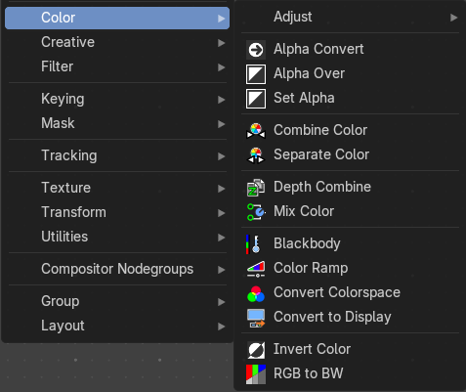
Here you find color related nodes.

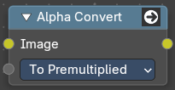
Alpha Convert
This node converts the alpha channel interpretation of an image from pre-multiplied to straight or vice versa. With a straight alpha channel you might run into artifacts at the borders when the pixels in the semi transparent areas.

Input

Image
The input image.

Properties

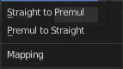
Mapping Type
Convert straight to premultiplied. Or convert premultiplied to straight.

Output

Image
The image output.

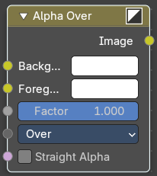
Alpha Over
The Alpha Over node is used to layer images with an alpha channel on top of one another.
Where the foreground image pixels have an alpha greater than 0, the background image will be overlaid.

Inputs

Background
Input for the background image.

Foreground
Input for the foreground image.

Factor
Controls the amount of foreground image. A factor less than 1 will make the foreground more transparent.

Straight Alpha
Defines wether teh foreground ins in straight alpha form, which is necessary to konw for proper alpha composing. Images in the compositor are in premultiplied alpha form by default. So it should be false in most cases. But if, and only if, the foreground was converted to straight alpha form for some reason, this should be set to true.

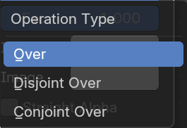
Properties

Over
The foreground goes over the background according to the alpha of the foreground.

Disjoint Over
The foreground goes over the background according to the alpha of the foreground while assuming the background is being held out by the foreground.

Conjoint Over
The foreground goes over the background according to the alpha of the foreground. But the foreground completely covers the background if it is more opaque but not necessarily completely opaque.

Outputs

Image
Image output.

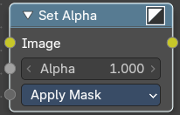
Set Alpha
The Set Alpha Node adds an alpha channel to an image.

Inputs

Image
Standard image input.

Alpha
The amount of Alpha can be set for the whole image by using the input field or per pixel by connecting to the socket.

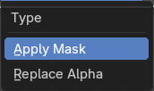
Type

Apply Mask
Multiply the alpha channel of the input image by the alpha input value.

Replace Alpha
Replace the alpha channel of the input image by the alpha input value.

Outputs

Image
The image output.

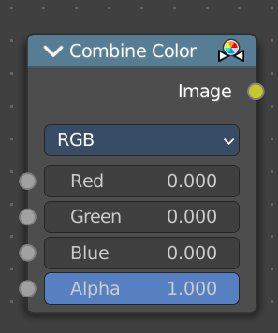
Combine Color
Combine single RGBA floating point channels into a single image.

Input

Mode
- RGB colour processing
- HSV colour processing
- HSL colour processing
- YcbCr converts an YCbCrA image to RGBA color space and unions the channels.
  - Y: Luminance, 0=black, 1=white
  - Cb: Chrominance Blue, 0=Blue, 1=Yellow
  - Cr: Chrominance Red, 0=Red, 1=Yellow
- YUV converts an YUVA image to RGBA color space. Note that U and V values range
from -0.5 to +0.5.

Input – RGB mode

R, G, B and A
The red, green, blue and alpha channels of an image.

Input – HSV mode

H , S and V
The Hue, Saturation and Value channels of an image.

Input – HSL mode

H , S and L
The Hue, Saturation and Luminescence channels of an image.

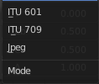
Input – YCbCRA mode

Y, Cb, Cr and A
Luminance, Chrominance Blue, Chrominance Red and Alpha input.

Properties

Modes
ITU 601, ITU 709, Jpeg. These are encoding standards for the YCbCrA color space.

Input – YUVA mode

Y, U, V and A
Luminance, Chrominance U, Chrominance V and Alpha channel.

Output

Image
The output image.

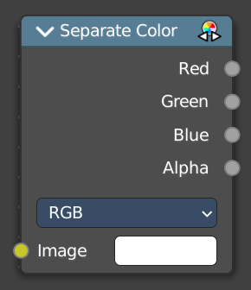
Separate Color
Separates the single RGBA channels from a single image.

Input

Mode
- RGB colour processing
- HSV colour processing
- HSL colour processing
- YcbCr converts an YCbCrA image to RGBA color space and unions the channels.
  - Y: Luminance, 0=black, 1=white
  - Cb: Chrominance Blue, 0=Blue, 1=Yellow
  - Cr: Chrominance Red, 0=Red, 1=Yellow
- YUV converts an YUVA image to RGBA color space. Note that U and V values range
from -0.5 to +0.5.

Output – RGB mode

R, G, B and A
The red, green, blue and alpha channels of an image.

Output – HSV mode

H , S and V
The Hue, Saturation and Value channels of an image.

Output – HSL mode

H , S and L
The Hue, Saturation and Luminescence channels of an image.

Output – YCbCRA mode

Y, Cb, Cr and A
Luminance, Chrominance Blue, Chrominance Red and Alpha input.

Properties

Modes
ITU 601, ITU 709, Jpeg. These are encoding standards for the YCbCrA color space.

Output – YUVA mode

Y, U, V and A
Luminance, Chrominance U, Chrominance V and Alpha channel.

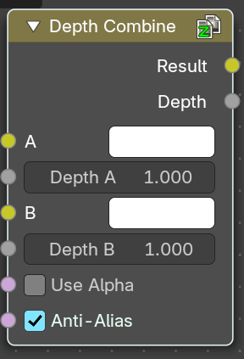
Depth Combine
The Depth Combine node combines two images based on their Z-depth maps. It overlays the images using the provided Z values to detect which parts of one image are in front of the other.

Inputs

A
The background image.

Depth A
Z depth of the background image.

B
The foreground image.

Depth B
Z depth of the foreground image.

Use Alpha
The chosen Image pixel alpha channel is also carried over. If a pixel is partially or totally transparent, the result of the Z Combine will also be partially transparent; in which case the background image will show through the foreground (chosen) pixel.

Anti-Alias Z
Applies Anti-Aliasing to avoid artifacts at sharp edges or areas with a high contrast.

Outputs

Result
If both Z values are equal, it will use the foreground image. Whichever Z value is less decides which image pixel is used. See Z-buffer.

Depth
The combined Z depth, which allows to thread multiple Z-combines together.

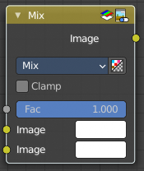
Mix Color
The Mix Node mixes images by working on the individual and corresponding pixels of the two input images. Called “MixRGB” in the shader and texture context.

Inputs

Factor
Controls the amount of influence the node exerts on the output image.

Image 1
Usually the background image. The image size and resolution sets the dimensions of the output image.

Image 2
Usually he foreground image.

Properties

Mix
Choose the different blending modes.
Add, Subtract, Multiply, Screen, Divide, Difference, Darken, Lighten, Overlay, Color Dodge, Color Burn, Hue, Saturation, Value, Color, Soft Light, Linear Light.

Clamp
Limit the highest color value to not exceed 1.

Outputs

Image
Image output.

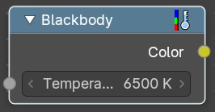
Blackbody
Convert a blackbody temperature to a rgb value.

Inputs

Temperature
The blackbody temperature.

Outputs

Color
The output RGB color.

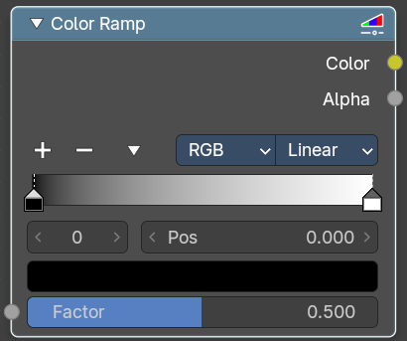
ColorRamp
The Color Ramp Node is used for mapping values to colors with the use of a gradient.

Inputs

Factor
The Factor input is used as an index for the color ramp.

Properties

Color Ramp
Color Ramps enables the user to specify a range of colors based on color stops. The color between the color stops gets interpolated.

Controls

+
Add a stop to your color ramp. The stop will be added after the selected one, in the middle to the next one.

-
Deletes the selected color stop from the list.


Tools menu

Flip Color Ramp
Flips the gradient, inverting the values of the color ramp.

Distribute Stops from Left
Rearrange the stops so that every step has the same space to the right.

Distribute Stops Evenly
Space between all neighboring stops becomes equal.

Eyedropper (pipette icon) E
An Eyedropper to sample a color or gradient from the interface to be used in the color ramp.

Reset Color Ramp

Resets the color ramp to its default state.

Color Mode

RGB
Blends color by mixing each color channel and combining.

HSV/HSL
Blends colors by first converting to HSV or HSL, mixing, then combining again. This has the advantage of maintaining saturation between different hues, where RGB would de-saturate, this allows for a richer gradient.


Interpolation

Ease
Uses an Ease Interpolation for the color stops.

Cardinal
Uses a Cardinal Interpolation for the color stops.

Linear
Uses a Linear Interpolation for the color stops.

B-Spline
Uses a B-Spline Interpolation for the color stops.

Constant
Uses a Constant Interpolation for the color stops.

Color Ramp
The color band. A click at one of the color stops makes it the active one. You can move the color stops by clicking at them and dragging them around.

Active Color Stop elements

Adjust the active color stop.

Choose active color stop
Choose the color stop by index.

Pos
The position of the active color stop. The range goes from 0.000 to 1.000

Outputs

Color
The color output.

Alpha
Alpha channel output.

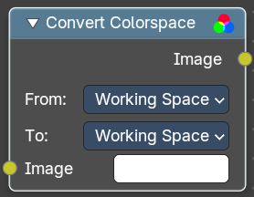
Convert Colorspace
Convert between color spaces.
Note that the conversion is skipped when converting between the same color spaces or to or from data spaces.

Input

Image
The input image.

Properties

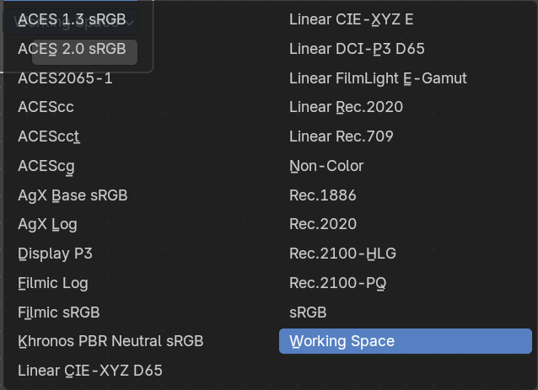
From
The current color space.

To
The destination color space.

Output

Image
The image output.

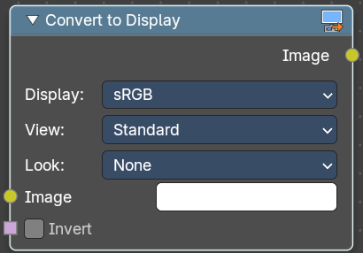
Convert to Display
Transforms an image from scene-linear color space into a display-referred format, using Blender’s color management pipeline. This is essential when working with raw data, custom view transforms, or prepping visuals for final output.

Inputs

Image
The input image in scene-linear space—typically the result of render layers, raw file input, or procedural compositing.

Invert
Reverses the display transform—useful for decoding display-referred images back to linear.

Properties

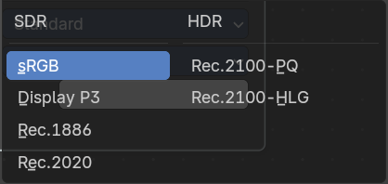
Display
Selects the target display device (e.g. sRGB, Rec.709, Display P3).
Determines how the image is mapped for viewing on screens.

View
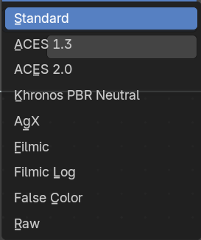
Applies a tone mapping curve (e.g. Standard, Filmic, Raw).
Controls contrast, highlight rolloff, and perceptual brightness.

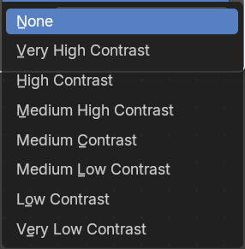

Look
Optional artistic adjustment layer (e.g. Medium Contrast, High Contrast, None).
Adds stylized tweaks on top of the view transform.

Output

Image
The display-referred result, ready for preview, export, or further compositing.

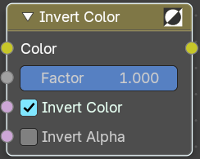
Invert Color
The Invert Node inverts the colors in the input image, producing a negative.

Inputs

Color
Standard input.

Factor
Controls the amount of influence the node exerts on the output image.

Invert Color
Invert the RGB values.

Invert Alpha
Invert the Alpha values.

Outputs

Color
Standard image output.
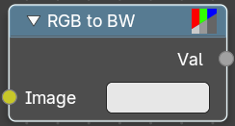

RGB to BW
The RGB to BW Node converts an RGB color image to a gray-scale image based at its luminance.

Inputs

Image
Color image input.

Outputs

Val
Gray-scale value output.

